How to Access Marketing II Resources in the Library Catalog

C:\Users\arkimmelman\AppData\Local\Microsoft\Windows\Temporary Internet Files\Content.IE5\81E13KZX\MC900014087[1].wmf

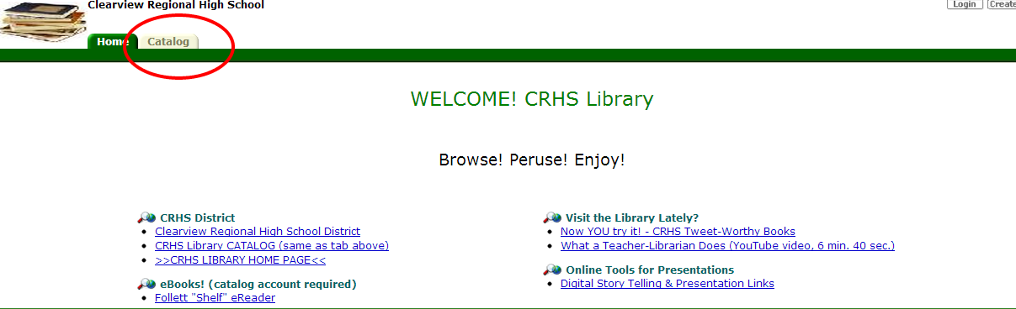

C:\Users\arkimmelman\AppData\Local\Microsoft\Windows\Temporary Internet Files\Content.IE5\T9XHLGGC\MC900014088[1].wmf 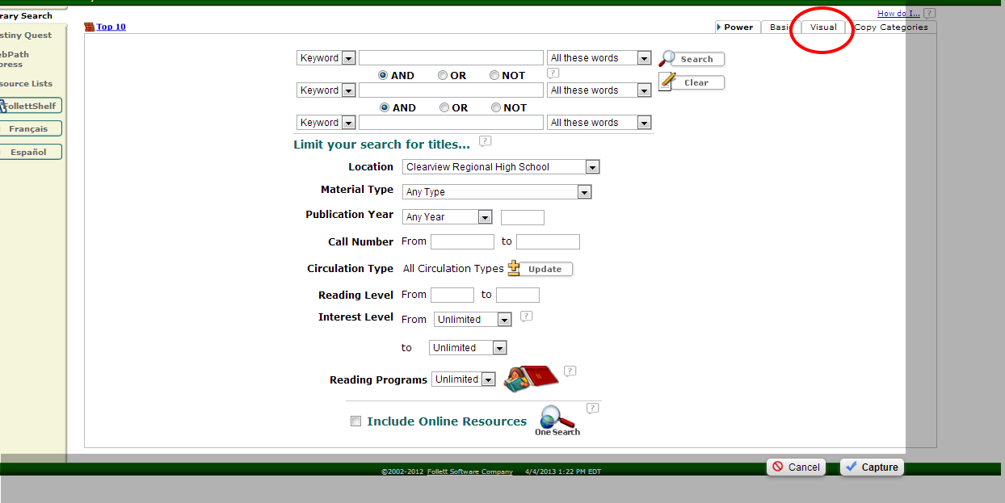

C:\Users\arkimmelman\AppData\Local\Microsoft\Windows\Temporary Internet Files\Content.IE5\81E13KZX\MC900014089[1].wmf 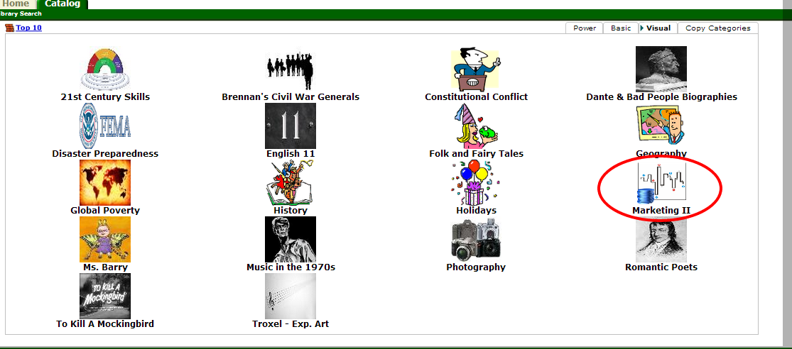

C:\Users\arkimmelman\AppData\Local\Microsoft\Windows\Temporary Internet Files\Content.IE5\Q5XO6LM5\MC900014090[1].wmf